Physics Stage 2: Nuclear Physics Test 2010.

Name: _________________________________________________ (40 marks)

- Within a nuclear reactor, uranium-235 is bombarded by a neutron to split into two daughter products also emitting two neutrons. Part of the nuclear equation is shown below.

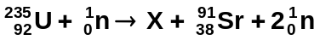

  - Write the nuclide for the missing daughter product labelled X. ________________
(1 mark)
  - What is the atomic and mass numbers of the daughter product:
Mass number ________ (1 mark) Atomic number ________ (1 mark)
- In terms of the properties of alpha and beta radiation, explain why alpha radiation cannot penetrate paper but beta radiation can. (4 marks)

____________________________________________________________________________________________________________________________________________________________________________________________________________________________________________________________________________________________________________________________________________________________________________________________
____________________________________________________________________________________________________________________________________________________________________________________________________________________________________
________________________________________________________________________________________________________________________________________________________
____________________________________________________________________________
____________________________________________________________________________
- For an atomic bomb to explode the amount of uranium-235 must reach critical mass and then the fission reaction created from a neutron induced chain reaction becomes uncontrollable. What is a neutron induced chain reaction and why does it need critical mass to explode?
(4 marks)

________________________________________________________________________________________________________________________________________________________________________________________________________________________________________________________________________________________________________________________________________________________________________________________________________________________________________________________________________________________________________________________________________________________________________________________________________________________
___________________________________________________________________________
______________________________________________________________________________________________________________________________________________________
___________________________________________________________________________
- A radioactive isotope has a count of 3.85 x 10³ decays in one hour. Calculate the activity of the source. (2 marks)

- Calculating the binding energy per nucleon in MeV of the helium-3 atom given the mass of
He-3 = 5.00 x 10⁻²⁷ kg. (4 marks)

- If the original activity of a sample is 42.0 kBq and it has a half-life of 4.00 days, how much will be left after 12.0 days? (3 marks)

- A radiation source and a detector can be used to measure the thickness of very thin aluminium foil during manufacture. Select, from the table, a suitable radioisotope to be used as a radiation source.

RADIOISOTOPE | MOST USEFUL RADIATION EMITTED | HALF-LIFE
Americium-241  Cesium-137  Cobalt-60  Iodine-131  Radium-223  Strontium-90 | alpha  gamma  gamma  beta  alpha  beta | 432 years  30 years  5.27 days  8.04 days  11.4 years  29 years

Choice: ____________________________________________ 1 mark)
Reason for choice: (3 marks)
____________________________________________________________________________
____________________________________________________________________________
____________________________________________________________________________
____________________________________________________________________________
____________________________________________________________________________
____________________________________________________________________________
____________________________________________________________________________
____________________________________________________________________________
____________________________________________________________________________
- The forming of a new element during radioactive decay is called transmutation. Explain why emitting alpha and beta radiation causes a transmutation but emitting gamma radiation does not. (3 marks)

____________________________________________________________________________
____________________________________________________________________________
____________________________________________________________________________
____________________________________________________________________________
____________________________________________________________________________
____________________________________________________________________________
____________________________________________________________________________
____________________________________________________________________________
____________________________________________________________________________
____________________________________________________________________________
____________________________________________________________________________
____________________________________________________________________________
____________________________________________________________________________
____________________________________________________________________________
____________________________________________________________________________
____________________________________________________________________________
____________________________________________________________________________
- A miner in a uranium mine is unaware that he is breathing in radon-222 gas, an alpha emitter. The gas has a very long half life with an activity of 3.40kBq which will be unchanged during his time in the mine. Each decay of the isotope releases 3.8 x 10⁻¹² J of energy into the body and that the radioisotope is not eliminated from the body as it settles into the tissue of his lung. After a month the gas is discovered and the mine closed (assume a month is 30 days).

- Calculate the total energy the miner absorbed into his lungs during this time. (2 marks)

- Calculate the absorbed dose he received in one month if he has a mass of 75 kg. (If you were unable to obtain a value for (a) above use 0.035 J) (2 marks)

- Calculate the dose equivalent if the alpha radiation has a quality factor of 20. (2 marks)

- Should the miner be concerned about his exposure? Explain. (2 marks)
________________________________________________________________________
________________________________________________________________________
________________________________________________________________________
________________________________________________________________________
________________________________________________________________________
________________________________________________________________________
- Determine the half-life of the substance from the graph.

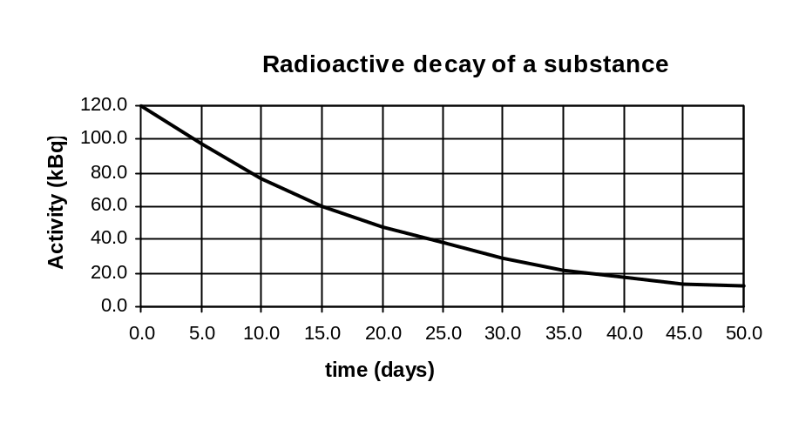

Half-life = _________________________ (1 mark)

- When Pu-238 (atomic number 94) is bombarded with a neutron, fission occurs to form Sn-128 (atomic number 50), Ru-108 (atomic number 44) and some neutrons.

a. Complete the nuclear equation showing the number of neutrons released. (1 mark)

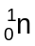 + 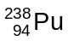 → 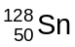 + 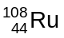 + _____

b. How much energy is released per reaction using the information on your data sheet and below. (3 marks)

Pu-238 = 396.82 x 10⁻²⁷ kg
Sn-128 = 212.33 x 10⁻²⁷ kg
Ru-108 = 179.13 x 10⁻²⁷ kg

